Akram Ibrahim – 211645

Progrmacion Orientada a objetos

Fatcat

1. Open the editor for class Cat. Change the view of the editor from “Source

Code” to “Documentation” view using the control in the top right of the editor

window. How many methods does the class Cat have? El gato tiene 12 metodos.

1. How many of the Cat’s methods return a value? 5 metodos
2. How many parameters does the sleep method have? 1 y es un numero entero para saber cuanto tiempo quieres que duerma
3. Try calling some of your cat’s methods interactively, by using the cat’s popup menu. The interesting methods are all “inherited from Cat.”

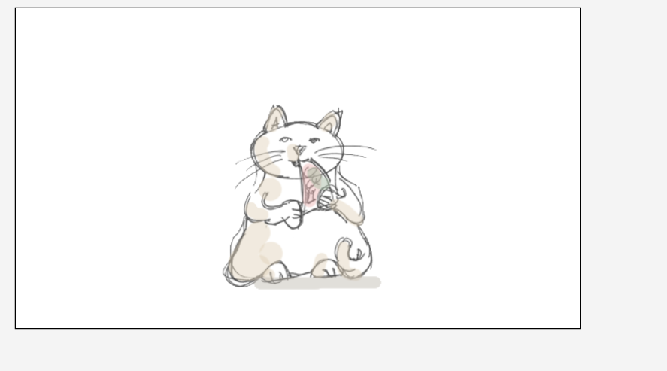

1. Is the cat bored? How can you make it not bored?

1. Open the editor for class MyCat. (This is where you will write the code for all the following exercises.)
2. Make the cat eat when it acts. (That is, in the act method, write a call to the eat method.) Compile. Test by pressing the Act button in the execution controls.

1. Make the cat dance. (Don’t do this interactively—write code in the act method to do this. When done, click the Act button in the execution controls.)

1. Make the cat sleep.

1. Make the cat do a routine of your choice, consisting of a number of the available actions in sequence.

[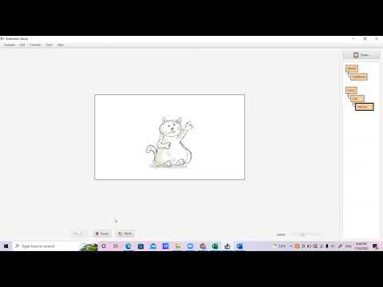](https://www.youtube.com/embed/aAoxqagjBPQ?feature=oembed)

1. Change the act method of your cat so that, when you click Act, if the cat is tired, it sleeps a bit. If it is not tired, it doesn’t do anything.

1. Change the act method of your cat so that it dances if it is bored. (But only if it is bored.)

1. Change the act method of your cat so that it eats if it is hungry.

1. Change the act method of your cat to the following: If the cat is tired, it sleeps a bit, and then it shouts hooray. If it is not tired, it just shouts hooray. (For testing, make the cat tired by calling some methods interactively. How can you make thecat tired?)

1. Write code in the act method to do the following: If your cat is alone, let it sleep. If it is not alone, make it shout “Hooray.” Test by placing a second cat into the world before clicking Act.

Preguntas:

1. ¿Qué es un método? Una serie de instrucciones que hace que una clase ejecute
2. ¿Qué son parámetros de un método? Son las variables que se les asignan a un método para que pueda ejecutarse, como por ejemplo cuando el fatcat quería dormir, teníamos que ponerle un parámetro de tiempo.
3. ¿Qué es la firma de un método? Es la combinación de los nombres con los argumentos o los tipos de parámetros
4. ¿Cómo se hace la llamada a un método? Para poder llamar a un método, se necesita que tenga una clase, y un objeto. Al tener eso, se escribe “getName ( )””
5. ¿Qué quiere decir la palabra “void” en la firma de un método? Es un método para no regresar el valor